Design Rationale

This is for Game Exam submission for the simple tile map game by Devlan McKenzie

# Introduction

This paper will discuss the reasons behind the creation of the exam submission of the game and will cover the methods used during its creation. This will reference previous design rationales used throughout the semester. This final iteration made use of the system created by the previous iterations to explore and develop content aimed towards children.

# Question

Can I use the system created previously to create content aimed towards children around the age of 9 years old. After researching more on what kind of content children like at the age of 9, I have extended the question to ask; can the new or updated content make use of brighter colours in the shades of blue, green, orange, red, yellow and purple.

This is done because children prefer brighter colours at an early age as their eyes aren’t fully developed yet and the brighter colours are more easily perceived than fainter colours. This will help children see the content and sustain their attention better than fainter colours would.

This leads to another question. Does the content in this iteration aid children in seeing the content in the game and help sustain their attention better than before. This directly leads into is the updated or new content brighter than before?

Can the previous systems be used to create a simple tutorial which describes movement and attack in the game?

# Process

Evaluation of the questions above reveals that all the questions asked can be solved using the previous systems described throughout the semester. This means that the application of the previous systems will allow me to further the intentions of the game and create or update content already made for this specific age bracket.

The research revealed that children like bright colours in the shades described above thus the main processes are the updating of content and altering of colour such that it falls in line with the research. This will be done by using Photoshop and opening the previous sprites created for the game, the brightening and altering of their colours such that they reflect the research, the saving and importing of the updated sprites and finally the implementation of the sprites in the final iteration of the game.

The process above will be expanded upon bellow to better show the changes made as it was mentioned that should I choose to explore these questions, it should be done in a very technical manner.

## Photoshop

Photoshop was used to create the initial content for the game and thus the content was saved in .psd files which could simply be reopened and updated. This iteration will see and update to all the tiles in the tile set as well as the majority of its other content in the game. This includes players and enemies such as the goblin and ogre and structures like the spawning huts.

### The previous sprites

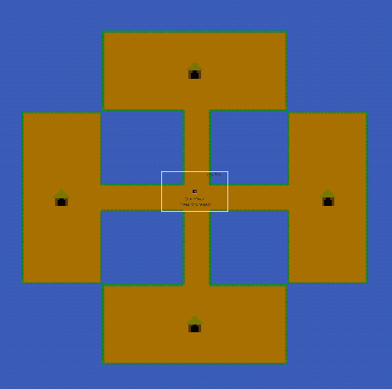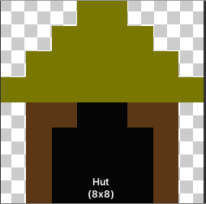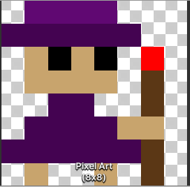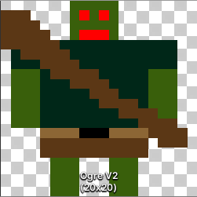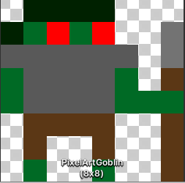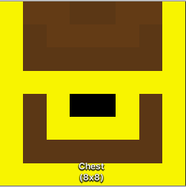

### The updated sprites

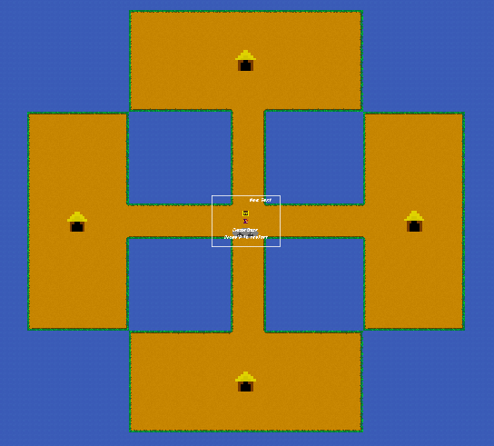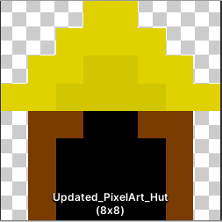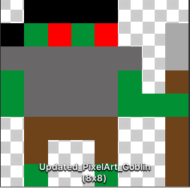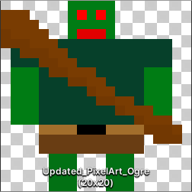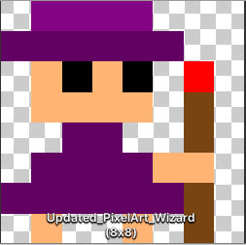

As you can see from the pictures displayed above the overall appearance is brighter and utilized the colours in shades of orange, blue, green, red, yellow and purple.

### Tutorial Content

The content for the tutorial needed to cover the controls in the game which included the WASD and Arrow keys and the Left Mouse Button. These would control movement and attack and would be displayed so that children could learn the controls.

These would have to be created using the previous methods used this semester which would include creativity in iterative design to create art assets. This would be done in Photoshop and implemented as a sprite much like the prior art assets.

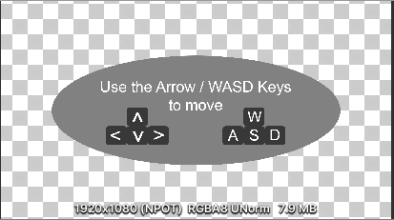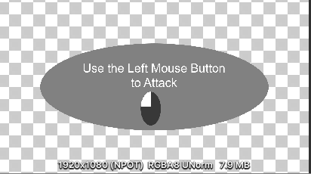

### The Implementation

These assets where imported and used in Unity in the methods described previously; the use of sprite renderers and Unity`s Tile map System. The map while exactly the same was completely remade in order to use these newer brighter tiles and the use of custom physics shapes was implemented again.

# Reflection

In conclusion the questions initially proposed were answered and have shown that the system created can be applied to discover more about art assets in an effective manner. The system can be used for a variety of age brackets and can aid in the implementation of art for that age bracket.

The system thus can be used to create content aimed towards children around the age of 9 years old, the new content does make use of brighter colours in the shades of blue, green, orange, red, yellow and purple. This content now aids the target audience to distinguish different art assets and better sustains their attention. This means that the content is indeed brighter than before and the previous systems were used to implement a simple tutorial which describes movement and attack. These tutorial assets were deliberately made duller so that they were in contrast with the background and thus allowed the target audience to better distinguish them.

# Future Plans

This will be the exam submission and thus there likely won’t be a future iteration however, in the future one could add an ammunition system and additional attacks which will make the game more replay able. The addition of rewards to provide player incentive with regards to game play and a high score system to introduce game mastery and competitive gaming.